Topic: Using a USB Flash Drive
When I am done this lesson, I will know:
- What a USB flash drive is
- What you can use a USB flash drive for
- How to save a file on a USB flash drive
- How to safely eject a USB flash drive

Pre and Post Self-Assessment
 | Pre | Pre | Post | Post
 | Yes, I know this | No, I want to learn this | Yes, I know this | I still need more practice to learn this
I know what a USB flash drive is
I know what I can use a USB flash drive for
I know how to save a file on a USB flash drive
I know how to safely eject a USB flash drive


New Words and Terms

USB flash drive
memory
storage capacity
eject device
What is a USB Flash Drive?
A USB flash drive is a small portable storage device that has flash memory and an integrated Universal Serial Bus (USB). Flash memory is a type of computer chip. The USB plugs into a USB port on your computer. It allows you to store information or files and transfer data to and from your computer(s).
Other common names for a USB flash drive:
- Thumb drive
- USB
- Pen drive
- Memory stick
- Flash drive
- Travel drive
- Jump drive
Memory key
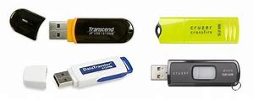
A USB flash drive is useful because it is small, durable and can allow you to take your computer files with you. There are many different makes, models and sizes.
You can save many different types of information on a USB flash drive. Some things you can save:
- Photos
- Songs
- Documents
Videos
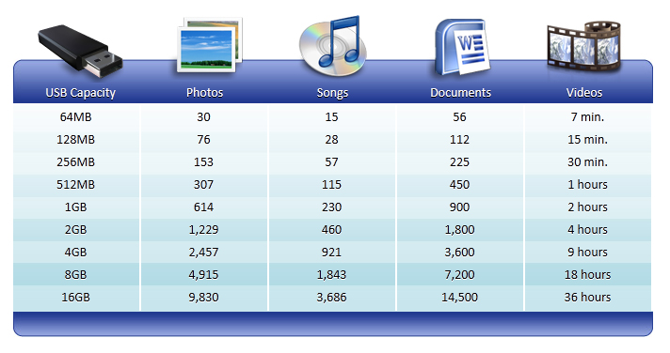
A USB flash drive will hold a different amount of information depending on its storage capacity. The chart below gives you an idea of how much information different USB drives will hold:

Check Your Knowledge
- How many photos can you store on a 4 GB USB flash drive?
- How many documents can you store on a 1 GB USB flash drive?
- How many hours of video can you store on a 16 GB USB flash drive?

How to Find a File on a USB Flash Drive
- Plug it into any USB port on a computer. A USB port can be located in many different places depending on the computer. The symbol for a USB port looks like:
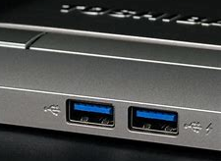
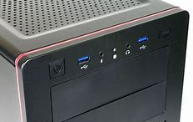
Here are some examples of USB ports on a laptop and computer tower. They are usually located along either side or the back of a laptop. They can be located on the front or back of a computer tower.

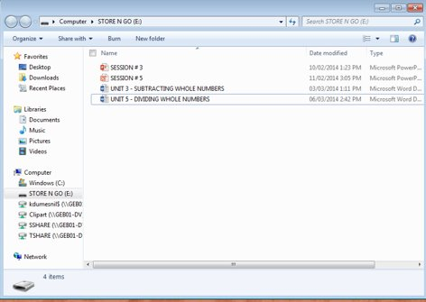
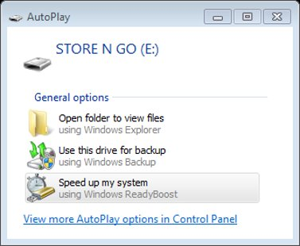
- Once you plug your USB flash drive into the USB port, the USB flash drive will be recognized by the computer as a new device and will usually be give the drive letter “e.” This message will pop up on your desktop:
- If you will not be opening any of the files currently saved on your memory stick, you can close this box. If you would like to open a file saved on your memory stick, simply click on Open folder to view files. A box that looks like this will appear. You will be able to see the files saved on your USB flash drive.

- If you need to find a file saved on your USB flash drive, you can also click on the File Explorer icon on the task bar when your USB flash drive is plugged into the USB port. This box will pop up:
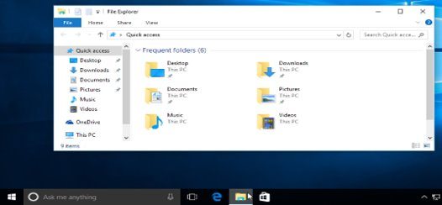
On the left-hand side you can scroll until you find the name of your USB flash drive.
How to Save a File on a USB Flash Drive
There are generally five steps to saving a file:
- Click “FILE” from inside the application or software you are working in. This is usually in the upper left-hand corner of your screen.
- Click “SAVE AS.”
- Choose where you want the file to be saved. Choose our USB flash drive.
- Change the file name.
- Click “SAVE.”
How to Safely Remove a USB Flash Drive
- Click on the white arrow on the right hand side of the task bar.

- Click on the USB icon.
- Click on “Eject Device.” This may say Eject and an actual device name like in the example below.
- Remove the USB Flash Drive.

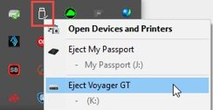

Try this/Practice
- Plug your USB flash drive into the computer.
- Open a blank document in Word.
- Type the word “TEST” into the document.
- Click “FILE” in the upper left hand corner.
- Click “SAVE AS.”
- Click on “Removable Disk” or “E drive.”
- Type the word “TEST” into the file name box.
- Click “SAVE” at the bottom.
Now check that your file is saved by:
- Click on “File Explorer” on your task bar.
- Click on the E drive.
Now safely remove the USB flash drive.

Optional: I Want to Learn More
Review this tutorial “Bringing Your Files with You” on GCFGlobal to learn more about USB flash drives: https://edu.gcfglobal.org/en/computerbasics/bringing-your-files-with-you/1/

Ontario Adult Literacy Curriculum Framework Connection
Competency | Task Group(s)
Find and Use Information | Read Continuous Text (L3 - long sentences, specialized vocabulary)  Interpret Documents (L2 - making connections between parts of documents)  Extract Information from Films, Broadcasts and Presentations
Communicate Ideas and Information | Complete and Create Documents (L2 - pre and post assessment)
Using Digital Technology | Perform Digital Tasks with Multiple Steps  Understand Text, Icons or Both

